**Name Chirag Rana**

**SE COMPS**

**2018130043**

**Experiment 6- PHP**

**AIM**: Create an opinion poll application consisting of following screens. Poll may be regarding any topic other than Javascript library.

**THEORY**:

## What is PHP?

PHP is a server side scripting language. that is used to develop Static websites or Dynamic websites or Web applications. PHP stands for Hypertext Pre-processor, that earlier stood for Personal Home Pages. PHP scripts can only be interpreted on a server that has PHP installed.

The client computers accessing the PHP scripts require a web browser only.

A PHP file contains PHP tags and ends with the extension ".php".

## **Architecture of a PHP Application**

## 

**Writing Comments**

Like many other languages, PHP also has the ability to add comments. This is important for annotating your code for human readers but in a way that the browser doesn’t try to execute it. In PHP, you have several ways for that:

* // — Denotes comments that only span one line
* # — Another way of producing single-line comments
* /*...*/ — Everything between /* and */ is not executed, also works across several lines

### Types of Data

Variables can take on different types of data:

* **Integers** — Integers are non-decimal numbers between -2,147,483,648 and ,147,483,647. They must have at least one digit and no decimal point. It can be in decimal, hexadecimal or octal.
* **Floats** — This is the name for numbers with a decimal point or in exponential form.
* **Strings** — This simply means text, we will talk about it in detail further below.
* **Boolean values** — Meaning true/false statements.
* **Arrays** — Arrays are variables that store several values. We will talk about them in detail further below.
* **Objects** — Objects store both data and information on how to process it.
* **Resources** — These are references to functions and resources outside of PHP.
* **NULL** — A variable that is NULL doesn’t have any value.

There is no need to declare PHP variables in a certain way. They automatically take on the type of data they contain.

Defining Variables:

To do anything with variables, you first need to define them. In PHP, you denote a variable using the $ sign and assign its value using =. A typical example:

**A few important points:**

* Variables need to start with a letter or underscore (_) and can only be comprised of alpha-numeric characters
* PHP variables are case sensitive, that means $myVar and $myvar are not the same thing
* If your variable consists of more than one word either write it $my_variable or $myVariable

**Predefined Variables**

PHP also comes with a number of default variables called superglobals. That’s because they are accessible from anywhere, regardless of scope.

* $GLOBALS — Used to access global variables from anywhere inside a PHP script
* $_SERVER — Contains information about the locations of headers, paths, and scripts
* $_GET — Can collect data that was sent in the URL or submitted in an HTML form
* $_POST — Used to gather data from an HTML form and to pass variables
* $_REQUEST — Also collects data after submitting an HTML form

**Code:**

**Index.php:**

<!DOCTYPE html>

<html lang="en">

<head>

    <meta charset="UTF-8">

    <meta name="viewport" content="width=device-width, initial-scale=1.0">

    <title>Poll</title>

    <link rel="stylesheet" href="style.css">

</head>

<body>

    <div class="container">

        <div class="header">

            <h2>

                Coding Language - Opinion Poll

            </h2>

        </div>

        <form action="server.php" method="post">

            <p>What is your preferred language to Code?</p>

            <input type="radio" name="language" id="python" value="python">

            <label for="python">Python</label><br>

            <input type="radio" name="language" id="java" value="java">

            <label for="java">Java</label><br>

            <input type="radio" name="language" id="javascript" value="javascript">

            <label for="javascript">Javascript</label><br>

            <input type="radio" name="language" id="c++" value="c++">

            <label for="c++">C++</label><br>

            <input type="radio" name="language" id="c" value="c">

            <label for="c">C</label><br>

            <input type="radio" name="language" id="kotlin" value="kotlin">

            <label for="kotlin">Kotlin</label><br>

            <button type="submit"> OK </button>

        </form>

    </div>

</body>

</html>

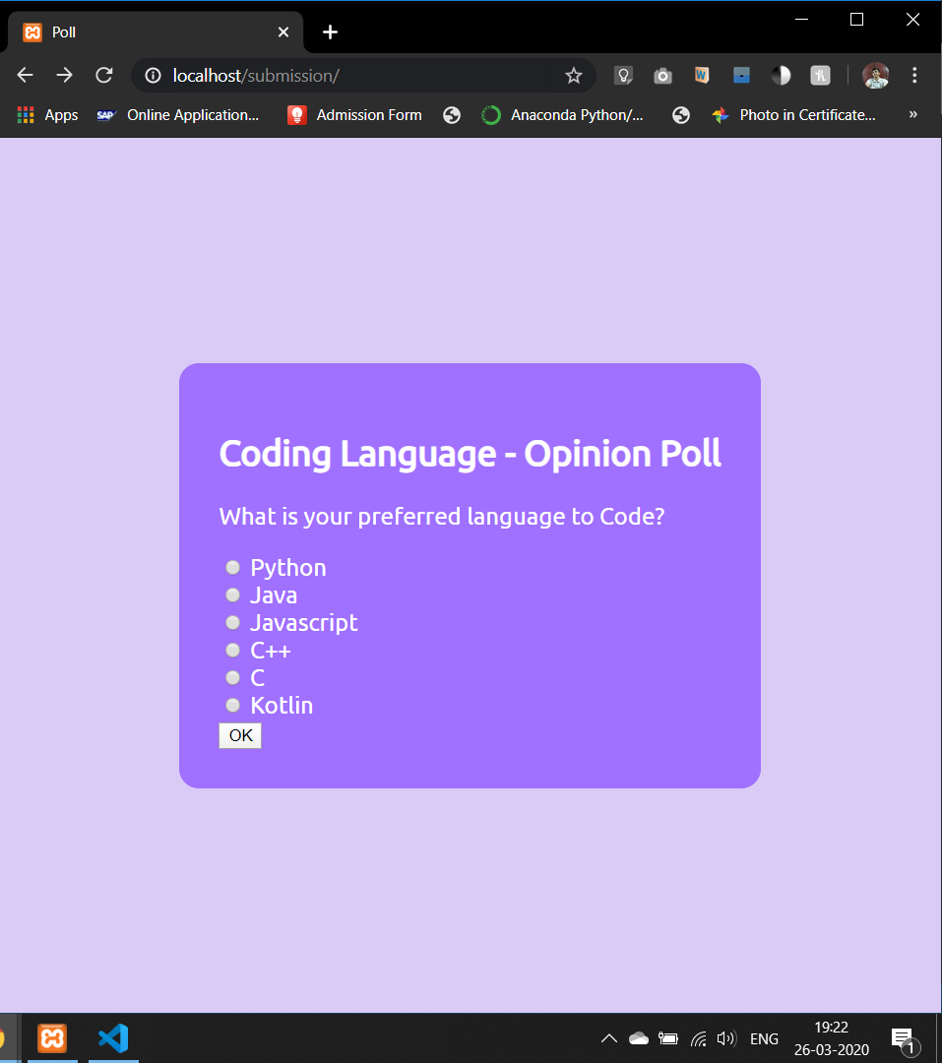**Output Screen Shot:**

**Submission.php:**

<?php

    $db = mysqli_connect('localhost','root','','databas_practice');

    if (!$db) {

        die("Failed to connect to MySQL: " . mysqli_connect_error());

    }

    $tcount = 0;

    $python = $java = $javascript = $c = $cpp = $kotlin = 0;

    $tcount = mysqli_fetch_assoc(mysqli_query($db,"SELECT COUNT(name) AS `count` FROM phpsubmission"))['count'];

    $python = mysqli_fetch_assoc(mysqli_query($db,"SELECT COUNT(name) AS `count` FROM phpsubmission WHERE name = 'python'"))['count'];

    $java = mysqli_fetch_assoc(mysqli_query($db,"SELECT COUNT(name) AS `count` FROM phpsubmission WHERE name = 'java'"))['count'];

    $javascript = mysqli_fetch_assoc(mysqli_query($db,"SELECT COUNT(name) AS `count` FROM phpsubmission WHERE name = 'javascript'"))['count'];

    $c = mysqli_fetch_assoc(mysqli_query($db,"SELECT COUNT(name) AS `count` FROM phpsubmission WHERE name = 'c'"))['count'];

    $cpp = mysqli_fetch_assoc(mysqli_query($db,"SELECT COUNT(name) AS `count` FROM phpsubmission WHERE name = 'c++'"))['count'];

    $kotlin = mysqli_fetch_assoc(mysqli_query($db,"SELECT COUNT(name) AS `count` FROM phpsubmission WHERE name = 'kotlin'"))['count'];

    mysqli_close($db);

?>

<!DOCTYPE html>

<html lang="en">

<head>

    <meta charset="UTF-8">

    <meta name="viewport" content="width=device-width, initial-scale=1.0">

    <title>Results</title>

    <link rel="stylesheet" href="style.css">

</head>

<body>

    <div class="container">

        <h3>Opinion Poll Results</h3>

        <p>What is your preferred language to Code?</p>

        <p><?php echo "$tcount";?> people have thus far taken in this poll: </p>

        <table>

            <tr>

                <td>Python got: <?php echo "$python";?> votes </td>

            </tr>

            <tr>

                <td>Java got: <?php echo "$java";?> votes </td>

            </tr>

            <tr>

                <td>Javascript got: <?php echo "$javascript";?> votes </td>

            </tr>

            <tr>

                <td>C got: <?php echo "$c";?> votes </td>

            </tr>

            <tr>

                <td>C++ got: <?php echo "$cpp";?> votes </td>

            </tr>

            <tr>

                <td>Kotlin got: <?php echo "$kotlin";?> votes </td>

            </tr>

        </table>

    </div>

</body>

</html>

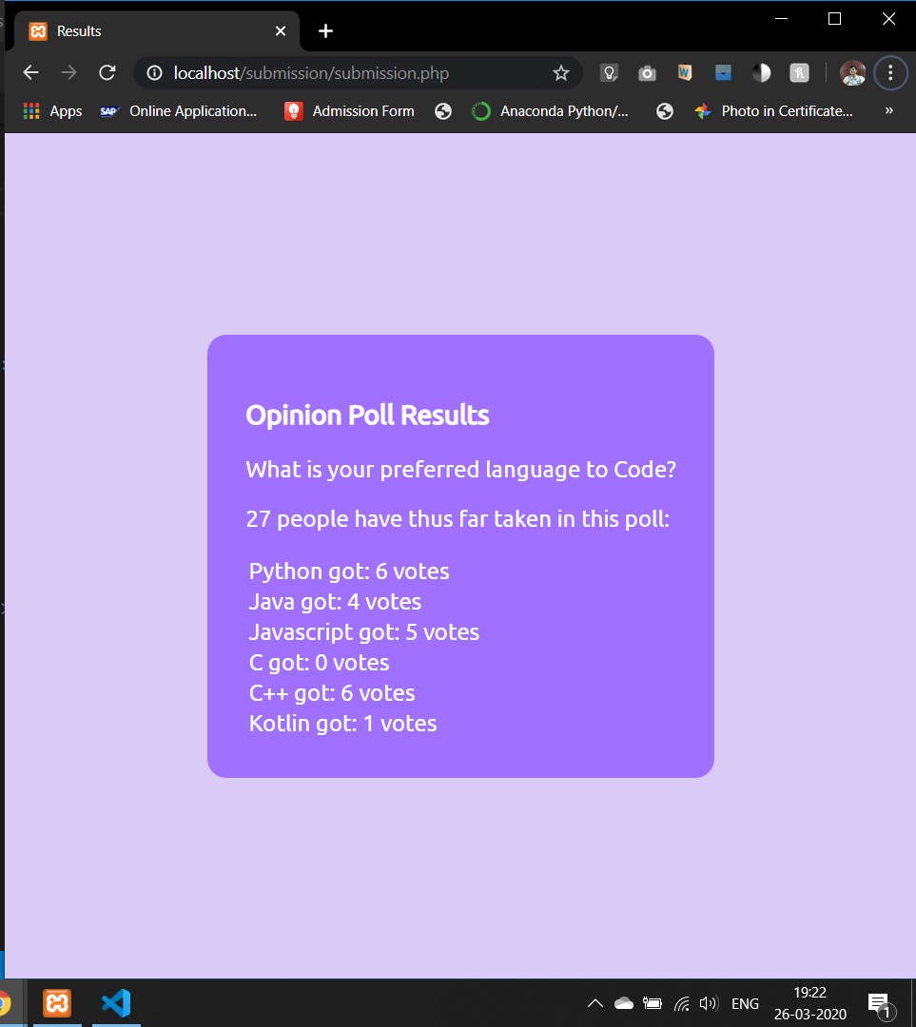**Output:**

**server.php:**

<?php

    session_start();

//  initiallizing variables

    $language = "";

    $errors = array();

    $sql = "";

// Form Validation

    if($_SERVER["REQUEST_METHOD"] == "POST"){

        if(empty($_POST["language"])){

            alert("You did not vote!");

        }

        else{

                $language = validated($_POST["language"]);

        }

    }

    function alert($message){

        echo "<script>alert('$message')</script>";

        exit(1);

    }

    function validated($data){

        $data = trim($data);

        $data = stripslashes($data);

        $data = htmlspecialchars($data);

        return $data;

    }

// Connect and CREATE to the Database

    $db = mysqli_connect('localhost','root','','databas_practice');

    if (!$db) {

        die("Failed to connect to MySQL: " . mysqli_connect_error());

    }

//  ADD the variable to the database

    $sql = "INSERT INTO phpsubmission (name) VALUES ('$language')";

    if(mysqli_query($db,$sql)){

        echo "New Record INserted";

    }else{

        echo "Error:" . mysqli_error($db);

    }

mysqli_close($db);

header("location: submission.php");

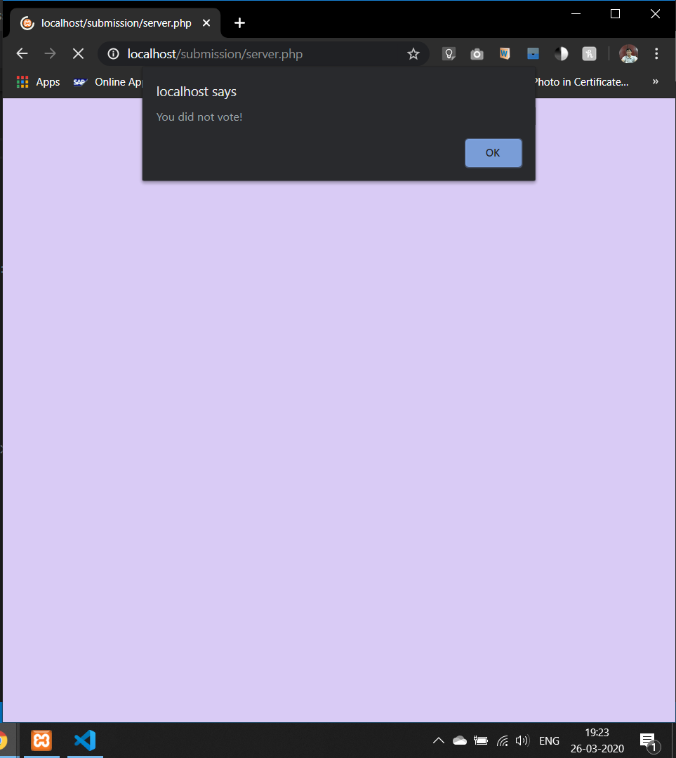**Output:**

**Style.css:**

@import url('https://fonts.googleapis.com/css?family=Ubuntu&display=swap');

.container{

    font-size: larger;

    background-color: #a070ff;

    height: fit-content;

    width: fit-content;

    padding: 2rem;

    position: absolute;

  top:0;

  bottom: 0;

  left: 0;

    right: 0;

    border-radius: 1rem;

  margin: auto;

}

body{

    background-color: #d9cbf5;

    font-family:'Ubuntu', sans-serif;

    color: white;

}

**Conclusion:**

1] I implemented php to create my first server side script.

2] I understood how to attach a database to the website via backend.

3] I used Xampp Server to host my scripts.